|  |  |  |
| --- | --- | --- |
|  | **Eastern Mediterranean University** **School of Computing and Technology**  **Department Computer Studies and Information Technology**  ***ITEC314 – Multiplatform Programming*** **Final Exam** |  |

**Instructor : Cem Yağlı**

**Date & Time : 12 January 2020 16:30**

**Duration : 3 Hours.**

**Q1. Complete the method named edit_Patient(). (7 points)**

**Q2. Complete the method named “backup_Patient()”, as it will run properly and pass the test**

**(8 points).**



**Q3. Complete the method named “list_Operation()”, as it will give the following output. (10 points)**

**HINT**: You have to use nested Iterator Loops to join the List Arrays: lstOperation, lstAppointment, lstPatient, lstOperationType and lstReceipt. Also may need to look the exercises document ([Tutorials 10 for Final (1).doc](https://teams.microsoft.com/l/file/0b1fdefe-4d2e-410a-84ea-aa18d55c691b?tenantId=9696b0a8-9e29-43ab-9fe5-b03aa9431d88&fileType=doc&objectUrl=https%3A%2F%2Fdoguakdeniz.sharepoint.com%2Fsites%2FITEC314772%2FShared%20Documents%2FGeneral%2FLab%20Work%2FTutorials10_for_Final%20(1).doc&baseUrl=https%3A%2F%2Fdoguakdeniz.sharepoint.com%2Fsites%2FITEC314772&serviceName=teams&threadId=19:2262deeb7c604339a8cc5ba7f6ac2dbe@thread.tacv2&messageId=1591952504608&groupId=34e5a7ff-3edc-4fbc-a140-a5ae5fe95e8b)) on the Teams 🡪 ITEC314 🡪 General 🡪 Files 🡪 Lab Works.

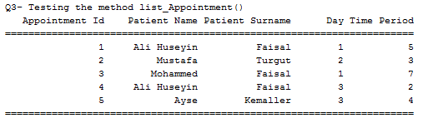

**Q4. Complete the method named “list_Operation()”, as it will give the following output. (10 points)**

**HINT**: You have to use nested Iterator Loops to join the List Arrays: lstOperation, lstAppointment, lstPatient, lstOperationType and lstReceipt. Also may need to look the exercises document ([Tutorials 10 for Final (1).doc](https://teams.microsoft.com/l/file/0b1fdefe-4d2e-410a-84ea-aa18d55c691b?tenantId=9696b0a8-9e29-43ab-9fe5-b03aa9431d88&fileType=doc&objectUrl=https%3A%2F%2Fdoguakdeniz.sharepoint.com%2Fsites%2FITEC314772%2FShared%20Documents%2FGeneral%2FLab%20Work%2FTutorials10_for_Final%20(1).doc&baseUrl=https%3A%2F%2Fdoguakdeniz.sharepoint.com%2Fsites%2FITEC314772&serviceName=teams&threadId=19:2262deeb7c604339a8cc5ba7f6ac2dbe@thread.tacv2&messageId=1591952504608&groupId=34e5a7ff-3edc-4fbc-a140-a5ae5fe95e8b)) on the Teams 🡪 ITEC314 🡪 General 🡪 Files 🡪 Lab Works.

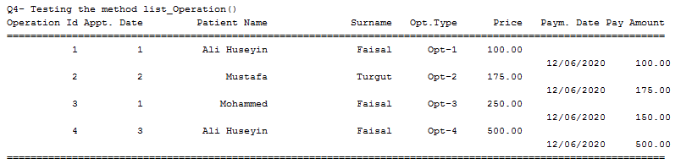

**Q5. Complete the given Jframe as it will be used to insert new Patient objects to lstPatient. (10 points)**

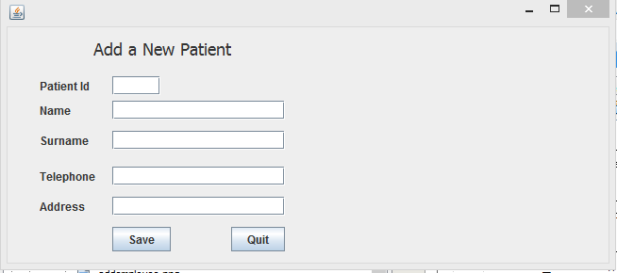

AT THE END OF THE EXAM UPLOAD YOUR ZIP (PROJEXT EXPORT FILE) TO TEAMS AND ALSO SEND ME AS AN E-MAIL ([cem.yagli@emu.edu.tr](mailto:cem.yagli@emu.edu.tr))

**The Class Relation Diagram**

Class **OperationType**

opt_id (PK)

opt_name

opt_price

Class **Patient**

pat_id (PK)

pat_name

pat_surname

pat_telephone

pat_address

Class **Receipt**

recs_id (PK)

date

payment

Class **Operation**

op_id (PK)

opt_id (FK)

apt_id (FK)

recs_id (FK)

Class **Appointment**

apt_id (PK)

pat_id (FK)

apt_day

apt_time